


Module Code & Module Title
CS6P05NI Project
Final Report

40% Individual Coursework
Submission: Final Submission
AY 2025 2026

Credit: 30 Credit Year Long Module

Student Name: Rohan Shrestha
London Met ID: 23056199
College ID: NP01NT4S240007
Assignment Due Date: Wednesday, April 22, 2026
Assignment Submission Date: Wednesday, April 22, 2026
Internal Supervisor: Shashwot Singh Shahi
External Supervisor: Aman Thakur
Word Count:
One Drive Link:
I confirm that I understand my coursework needs to be submitted online via MST Classroom under the relevant module page before the deadline for my assignment to be accepted and marked. I am fully aware that late submissions will be treated as non-submission and a mark of zero will be awarded.
Abstract

Table of Contents
1. Introduction 5
1.1. Project Description 5
1.2. Current Scenario 5
1.3. Problem Domain and Project as a Solution 5
1.4. Aim and Objectives 5
1.5. Structure of the Report 5
2. Background 7
2.1. About the End Users 7
2.2. Understanding the Solution 7
2.3. Similar Projects 7
2.4. Comparisons 7

Chapter 1: Introduction

1. Introduction

1.1. Project Description
This project involves the design and development of Vaultword, a secure password manager application intended to help users store and manage credentials safely. The application is built to address common password management problems such as password reuse, weak password selection, and difficulties remembering large numbers of passwords.
Vaultword provides a password vault that stores account credentials (e.g., website name, username, password) in an encrypted format. The key security principle of the project is that encryption is performed client-side, meaning sensitive data is encrypted on the user’s device before being transmitted to the backend. As a result, the server stores only ciphertext and cannot read user secrets, reducing the consequences of backend compromise. In addition, the system includes features that support secure user behavior, such as generating strong passwords and organizing entries for convenient retrieval.

1.2. Current Scenario
An average user has around 100 passwords, and it is estimated that after 2020’s global lockdown the average number of passwords have increased due to the result of people downloading more apps and using many sites or services on the internet and this number is in an upward pointing trend (Viezelyte, 2024).
Alphanumeric string with special characters or in simple words text passwords are the most used method for authenticating users particularly on the internet. They form the foundation of security policies and are not going to be less dominant method of authentication any time soon. Designers often make authentication mechanisms impose a scheme to enforce a composition policy which prevents user from selecting passwords that are too simple. (Anupam Das, 2014)
Although biometrics, hardware tokens, public-key certificates exist text passwords remain to be used because of its convenience, lack of custom hardware, simplicity, integration with preexisting tech. The transition costs is very significant to switch to other alternatives hence we will have to wait considerably to see the end of text based passwords. (Joseph Bonneau, 2012)

1.3. Problem Domain and Project as a Solution
A poll conducted by google on 2019 revealed that 52% of user reuse the same password for multiple accounts, 35% of users use a different password for all accounts and 13% of users reuse the same password for all their accounts which shows that password reuse is still a common practice (Google, 2019).
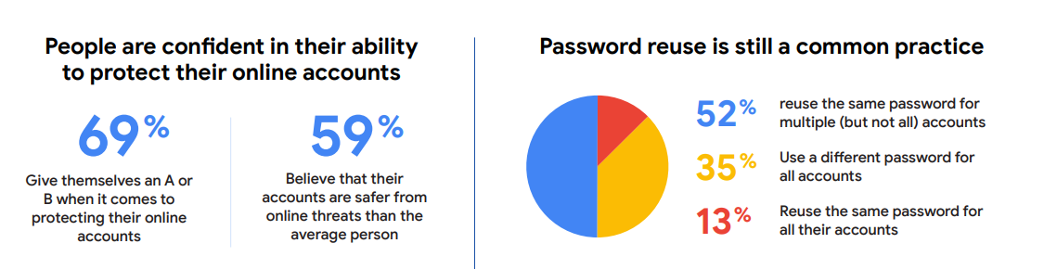
Figure 1: Poll result by Google / Harris Poll (Google, 2019).
Also, as per Verizon 2023 Data Breach Investigation Report (DBIR) 2023 the major cause of basic web application attacks is cause by poorly picked and protected passwords which dictates that password management remains a major cybersecurity vulnerability (Verizon, 2023). As per LastPass’ 2022 Psychology of Passwords Report 65% of users claim to have received some form of cybersecurity education but practice poor password hygiene, according to their study 62% of users reuse password or slight variations of the same password, despite 89% acknowledging that reused passwords are a significant security risk (LastPass, 2022).
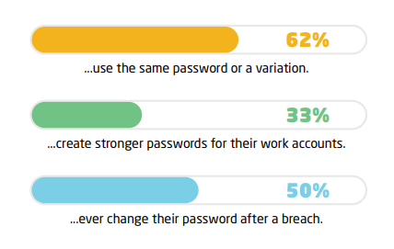
Figure 2: Survey result by LastPass (LastPass, 2022).
The project will be offering a secure and practical solution to the widespread problem of weak, reused and poorly managed passwords. The project focuses mainly on directly addressing the key issues identified in research including password fatigue, lack of strong password habits and the gap between cybersecurity awareness and real behavior. The project will implement a system where sensitive data is encrypted on the user’s device before transmission, meaning that even if the server is compromised no credentials are exposed. The project will also focus on simplifying secure habits and removing the need for memorizing multiple complex passwords, the project provides a convenient and user friendly tool that improves cybersecurity practices.

1.4. Aim and Objectives

1.4.1. Aim
The aim of this project is to develop a secure, encrypted password manager application that improves password hygiene that protects user credentials against unauthorized access, data breaches and password-based attacks.

1.4.2. Objectives
The objectives of the project are as follows:
- Design and implement a user authentication system
- Implement a secure key derivation mechanism that converts user master password into cryptographic keys
- Develop a password vault using AES-256 on the client side.
- Create backed API that stores only encrypted data and never receives plain text passwords.
- Implement password generation functionality to help users create strong, random passwords.
- Develop a user friendly and convenient way of storing, retrieving and managing passwords securely.

1.5. Structure of the Report

Chapter 2: Background

2. Background

2.1. About the End Users
The end users of Vaultword are primarily everyday internet users who maintain multiple online accounts for services such as email, banking, e-commerce, education platforms, and social media. This group often includes students and working professionals who may not have specialist cybersecurity knowledge but still face significant risks from phishing, credential stuffing, and data breaches.
As per the pre-survey conducted for this project it seems that risky habits remain common despite high awareness. Password reuse is widespread (36.4% often and 45.5% sometimes reuse passwords across accounts), and reuse with small variations is also reported (38.2% yes; 30.9% sometimes). At the same time, 90.9% are aware that password reuse increases the risk of compromise, showing a clear gap between security knowledge and real behaviour.
These users typically experience password fatigue, where the difficulty of managing many credentials leads to insecure coping strategies such as reusing passwords, choosing simple passwords, or saving them in browsers or unsecured notes. Therefore, the solution must prioritize both security and usability: it must be straightforward to adopt, quick to use, and able to reduce the cognitive burden of remembering credentials, while still applying strong cryptographic protections by default.

2.2. Understanding the Solution
Vaultword is based on a security model commonly used by modern password managers: a master password unlocks an encrypted vault. Instead of storing passwords in plaintext, the application protects all vault entries using strong symmetric encryption. The encryption key is not stored directly; instead, it is derived from the user’s master password using a key derivation function (KDF) such as PBKDF2 or Argon2. Key derivation increases resistance to brute-force attacks by making each password guess computationally expensive.
Once the vault is unlocked locally, the user can view, add, edit, and delete stored credentials. When changes are made, the updated vault is re-encrypted on the client side before being saved or synchronized. The backend server is designed to store only encrypted vault data and account metadata required for functionality, but it should not be able to decrypt the vault contents. In addition to storage, Vaultword supports password generation, enabling users to create long, random, and unique passwords. This is a practical mechanism to reduce reuse and improve password strength without increasing user effort.

2.3. Similar Projects

2.3.1. Proton Pass
Proton Pass is a relatively recent entrant in the password management space, developed by Proton AG, the Swiss privacy-focused company also known for Proton Mail and Proton VPN. It employs end-to-end encryption with 256-bit AES-GCM to secure all stored credentials, passkeys, notes, credit card details, and other sensitive items. This encryption ensures that only the user who holds the decryption key derived from the master password can access vault contents, and even Proton cannot decrypt user data. Proton Pass adopts a zero-knowledge security model, where encryption and decryption are performed exclusively on the user’s device before syncing with the cloud. This protects user data from server-side exposure and aligns with privacy expectations for sensitive credential management tools. The service is open source, allowing security experts to review the code, and has been independently audited to verify its implementation of cryptographic protections.


2.3.2. Bitwarden
Bitwarden is an open-source password manager designed to help users securely store, autofill, and manage their login credentials and other sensitive data across multiple devices and platforms. Bitwarden adopts a zero-knowledge encryption model, meaning all data entered into a user’s vault is encrypted on the client side using strong cryptographic standards before it is ever transmitted or stored on Bitwarden’s servers. At the core of Bitwarden’s security architecture is AES-256 end-to-end encryption combined with PBKDF2-SHA-256 (or optional Argon2id) key-derivation functions to produce strong cryptographic keys from the master password. Only the user, who knows the master password, retains the ability to decrypt vault contents; Bitwarden itself cannot access this information, which forms the basis of zero-knowledge encryption.


2.3.3. LastPass
LastPass is one of the most widely used commercial password managers, offering cross-platform support and centralized encrypted password storage. Its core design prioritizes strong encryption and user privacy through a zero-knowledge security model, meaning that sensitive data is encrypted on the user’s device before it is sent to the server, and only the user can decrypt it. Specifically, LastPass uses AES-256 encryption with PBKDF2-SHA-256 key derivation and salting, with hundreds of thousands of iterations to protect the master password and vault contents, making brute-force attacks computationally difficult. This local-only encryption approach ensures that LastPass employees or attackers who breach the servers cannot access user passwords directly.


2.4. Comparisons
Table 1: Similar projects comparision table
Features | LastPass | Bitwarden | Proton Pass | Vaultword
Type | Commercial, proprietary | Open source | Open source | Academic Project, Open source
Encryption Model | Client-side encryption | Client-side encryption | End-to-end encryption | Client-side encryption
Encryption Algorithm | AES-256 | AES-256 | AES-256-GCM | AES-256
Key Derivation Function | PBKDF2-SHA-256 | PBKDF2 | PBKDF2 | PBKDF2 / Argon2
Open Source Availability | No | Yes | Yes | Yes
Plaintext Password Storage | No | No | No | No
Password Generator | Yes | Yes | Yes | Yes
Hosting Model | Cloud-hosted | Cloud-hosted | Cloud-hosted | Self-hosted
Target Users | General users and enterprises | Privacy conscious users and enterprises | Privacy focused users | General users
Cost | Subscription-based | Free & paid | Free & paid | Free

Chapter 3: Development

3.1. Considered Methodologies
Different software development methodologies were considered to determine which would best support the project’s requirements and fulfill the expected outcomes.

3.1.1. Scrum Methodology
Scrum is an Agile-based framework designed for iterative and incremental software development. It organizes work into fixed-length cycles called sprints, typically lasting 2-4 week. Agile promotes incremental development through short iterations and continuous feedback. While Agile is highly effective for user-driven features and UI enhancements, it provides limited structure for formal risk analysis, which is crucial in security-critical systems. (Cockburn, 2002)
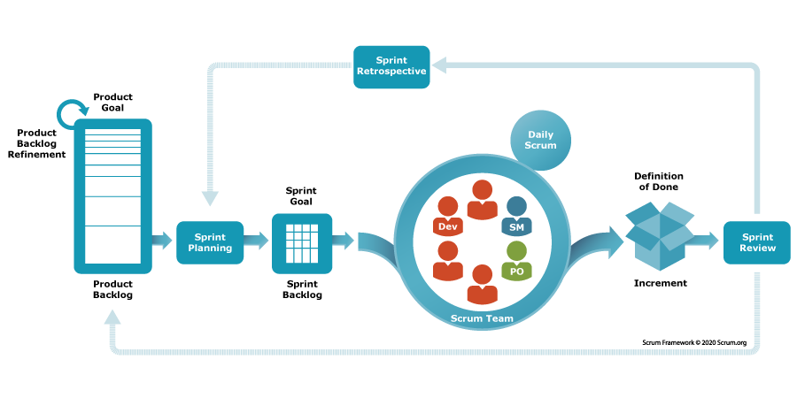
Figure 3: Scrum Framework Diagram. (Scrum.org, 2020)

3.1.2. Spiral Model
The Spiral Model integrates both iterative development and continuous risk assessment, it consists of repeated cycles containing planning, risk analysis, engineering, and evaluation. This makes it well-suited for security-sensitive environments, where early identification of vulnerabilities and incremental refinement are essential. Spiral Model’s effectiveness for complex systems involving high levels of uncertainty and technical risk is much higher than other methodologies considered. (Pressman, 2020)

3.1.3. Dynamic Systems Development Method (DSDM)
The Dynamic Systems Development Method (DSDM) is an Agile framework that emphasizes rapid and iterative development while maintaining strong project governance. DSDM requires consistent end-user availability, well-defined business roles, and structured team communication which may be less suitable for an individual academic project with limited stakeholder engagement. (Stapleton, 1997)
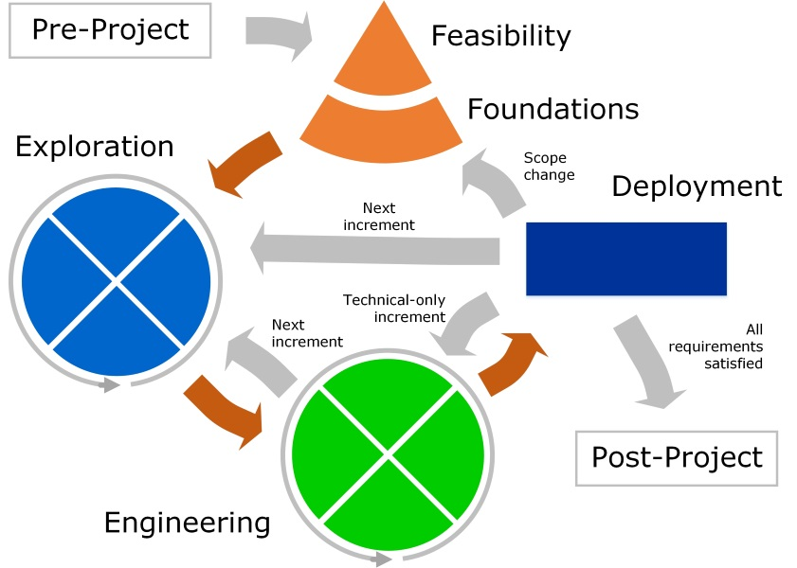
Figure 4: DSDM Framework.

3.2. Selected Methodology

3.2.1. Spiral Model
The project will follow the Spiral Software Development Life Cycle (SDLC) model, which is suitable for security-focused applications such as a password manager. The Spiral model combines iterative development with continuous risk analysis, making it effective for handling cryptographic features and sensitive data.
Each spiral cycle begins with planning and requirement analysis. This is followed by risk assessment, where potential threats are evaluated and appropriate mitigation strategies are considered. The next stage involves design and development. After each development cycle, testing and evaluation are carried out, including unit testing, integration testing, and security testing, to ensure correctness and robustness.
The spiral repeats until all major features are completed, after which the final system is deployed and maintained. This iterative approach ensures continuous improvement, early detection of issues, and a secure, reliable final product.
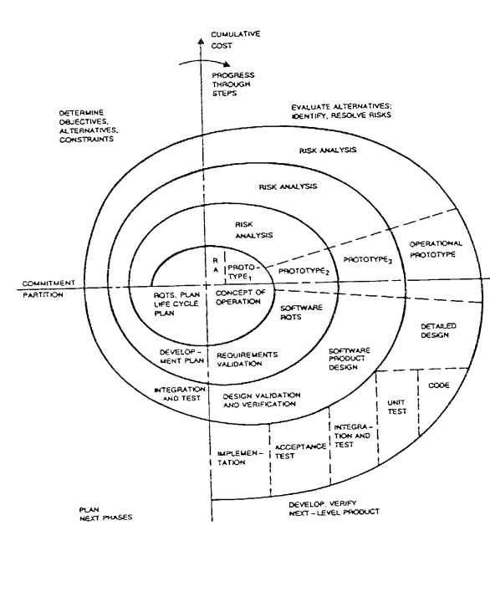
Figure 5: Spiral Model of Project Management. (Boehm, 1986)

3.3. Phases of Methodology

3.4. Survey Results

3.3.1. Pre-Survey Results
The purpose of the study was to investigate user awareness, practices, and difficulties pertaining to digital security and password management. According to the findings, the majority of users handle several online accounts and frequently have trouble remembering complicated passwords, which encourages risky behaviors like reusing or utilizing predictable passwords. Despite the fact that many respondents are aware of the security concerns associated with weak or reused passwords, secure password behavior is not necessarily the outcome of this understanding. The results also show a low uptake of specialized password managers, mostly because of issues with usability, trust, or unfamiliarity. Nonetheless, features like client-side encryption, secure password storage, automatic password generation, and user-friendliness were much sought after by consumers. The findings of the survey point out the necessity for a straightforward and safe password management system by pointing out a disconnect between user awareness and actual security behavior.

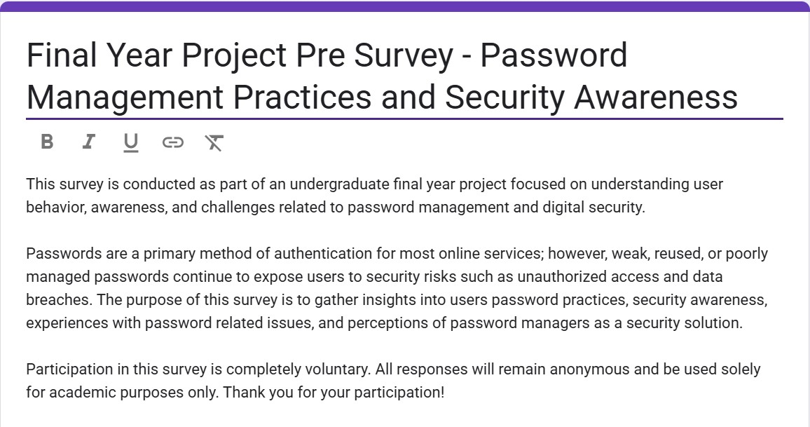
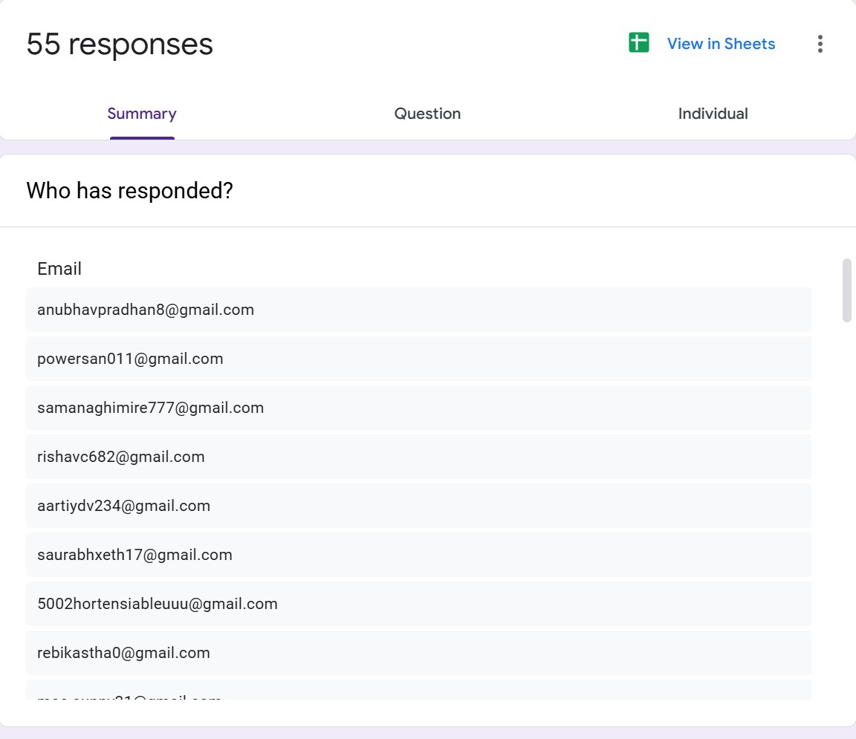
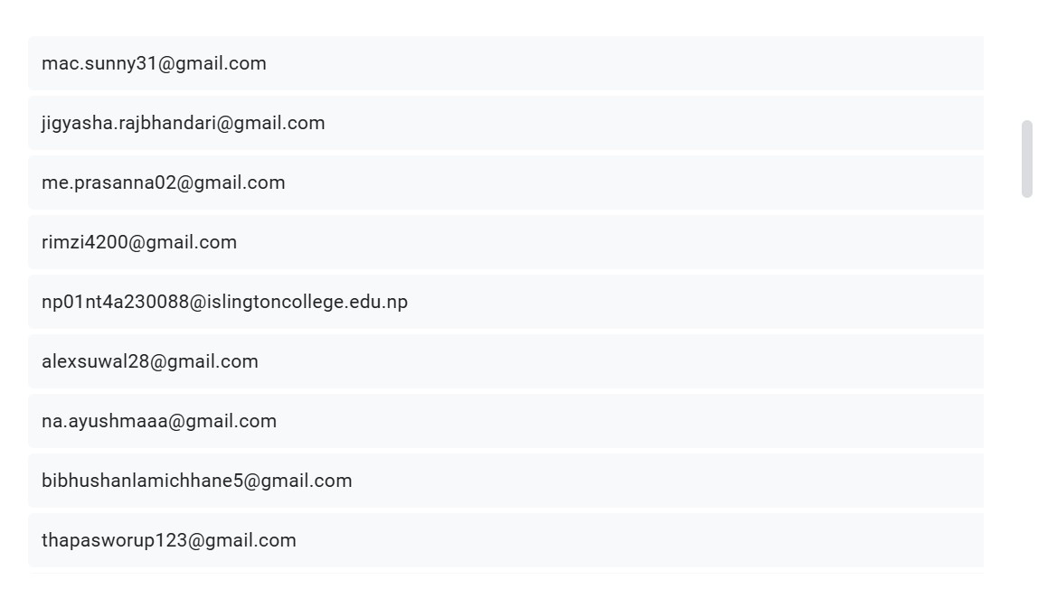
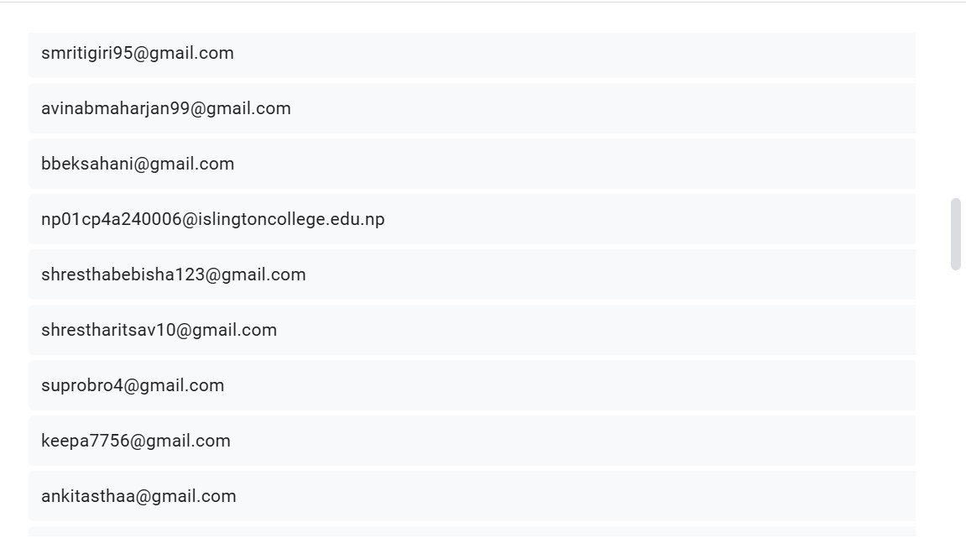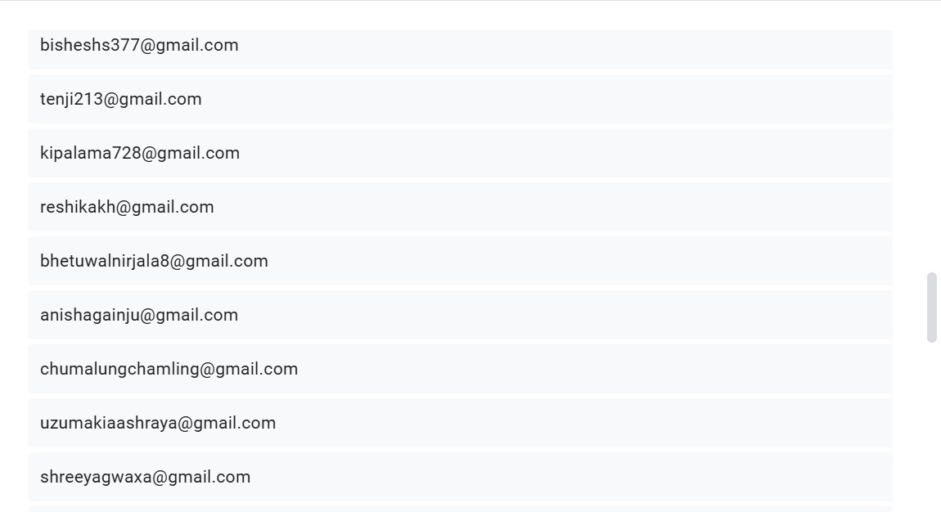
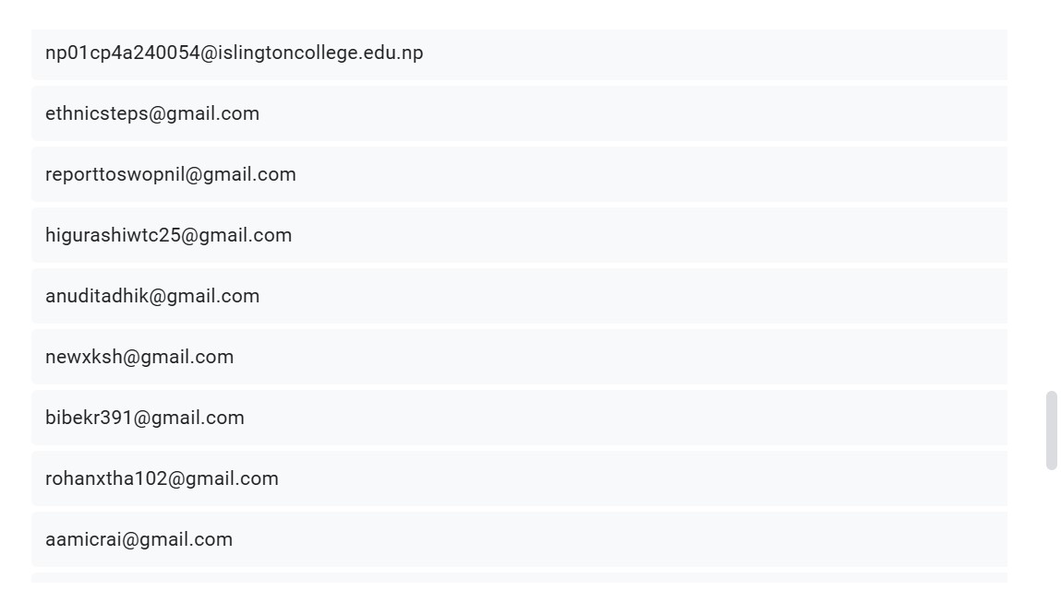
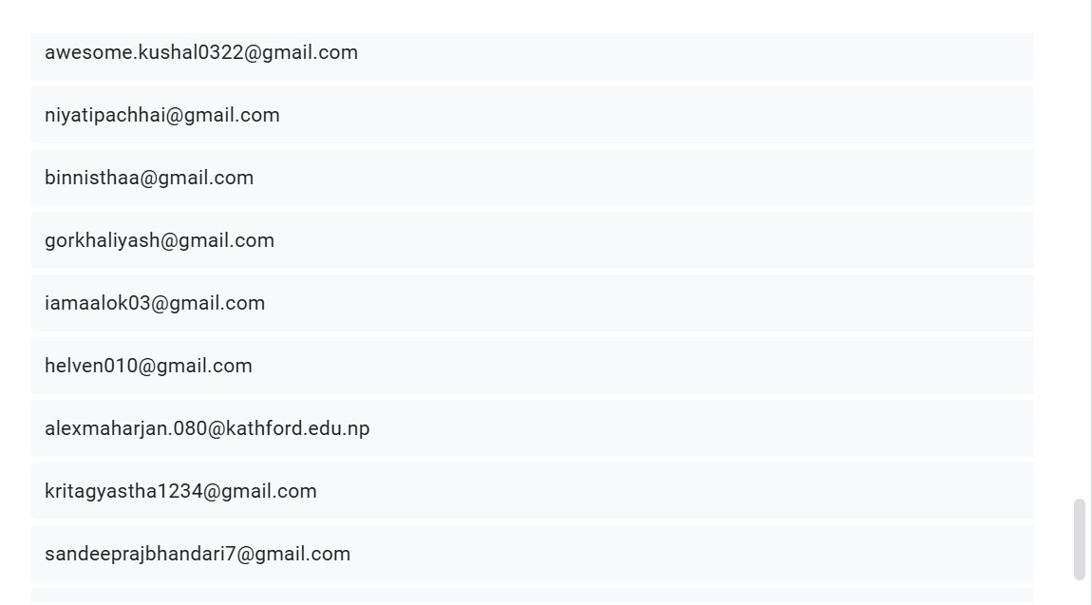
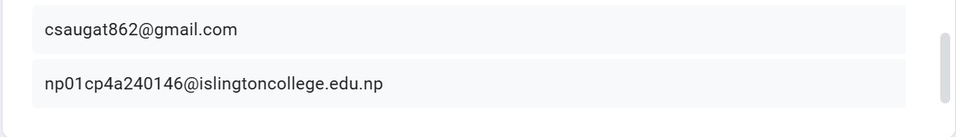

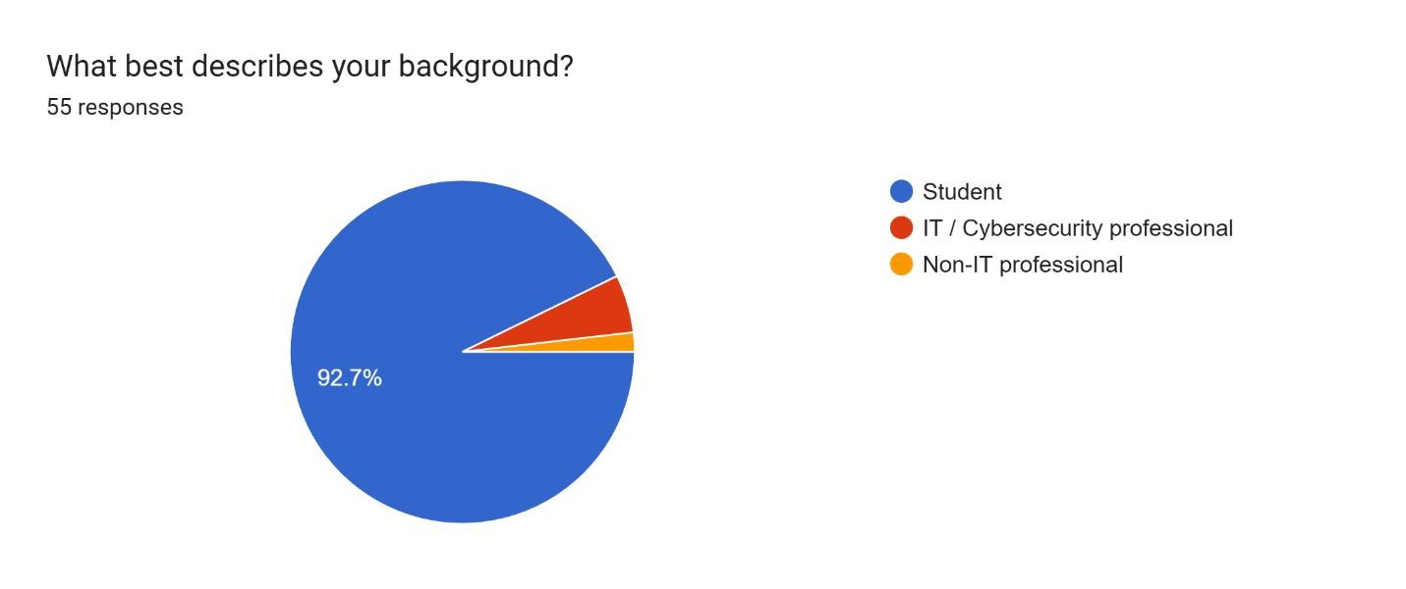
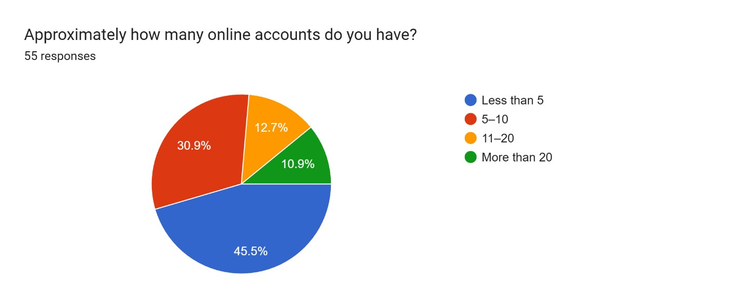
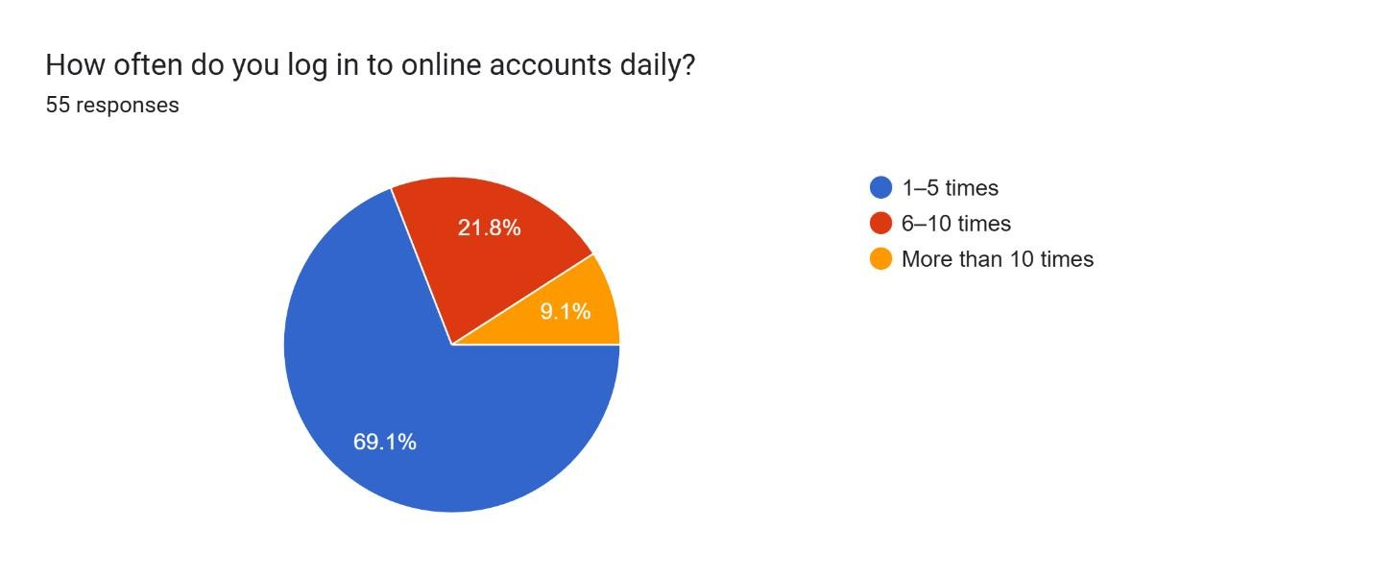
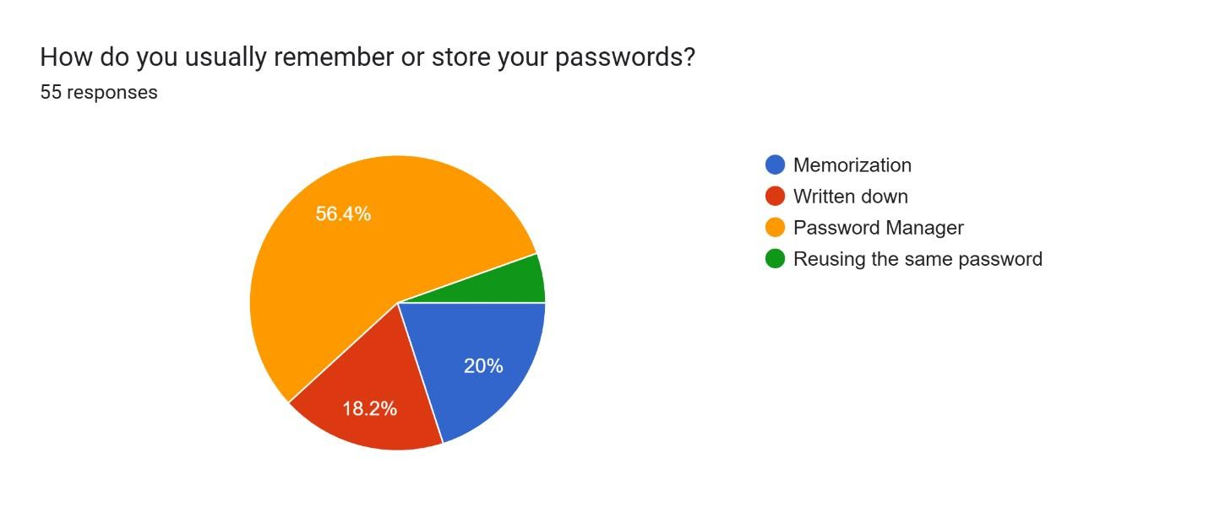
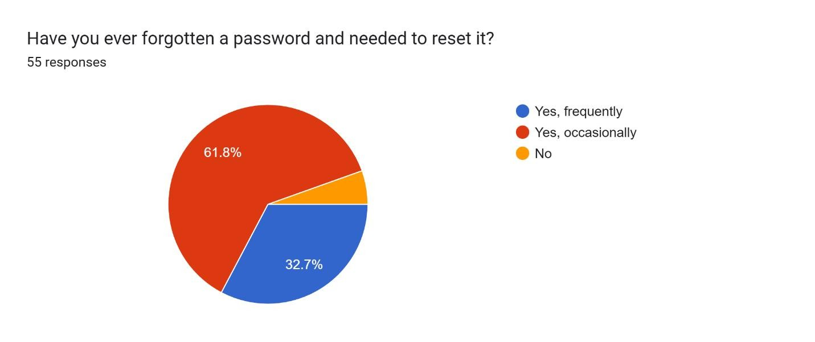
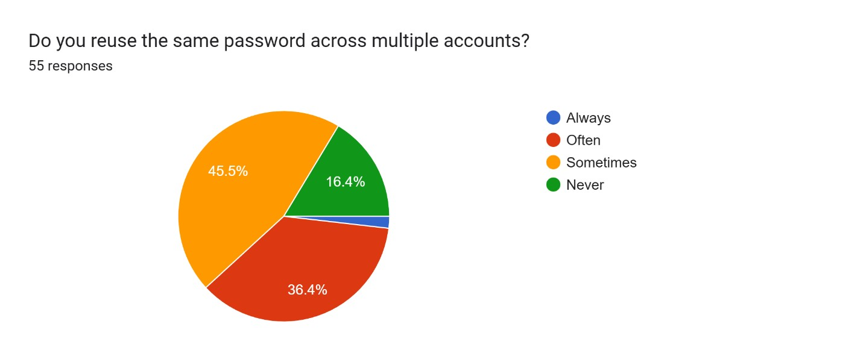
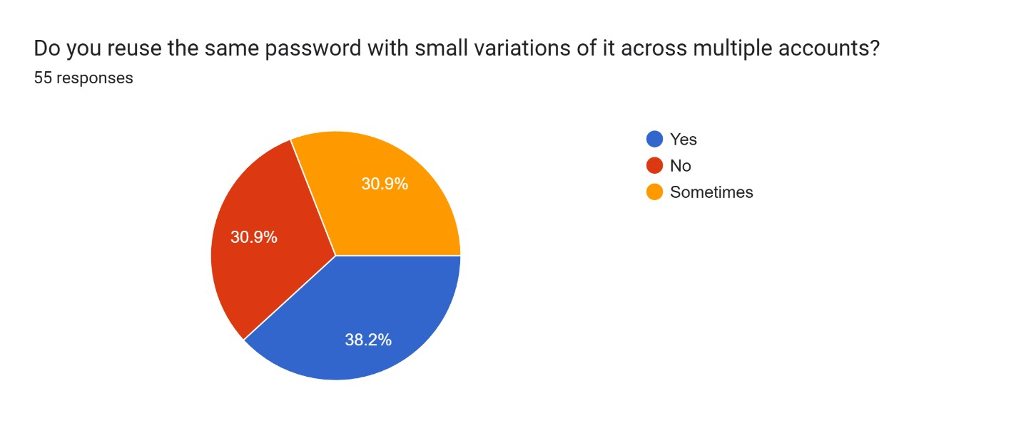
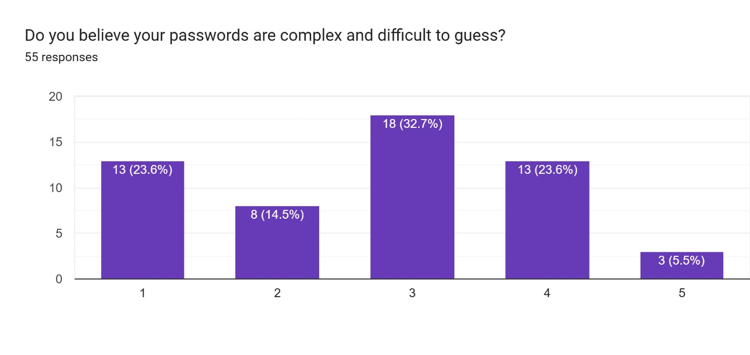
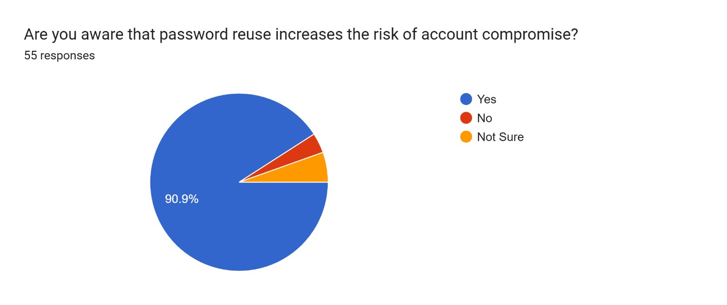
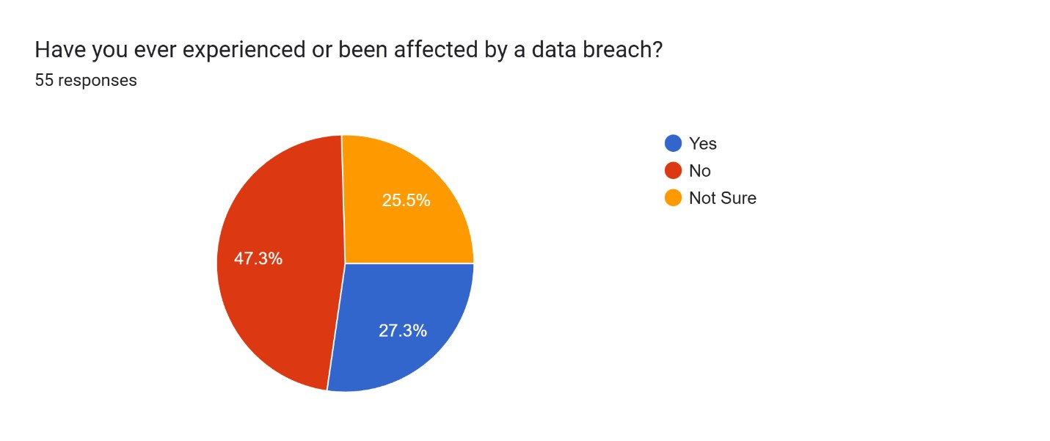
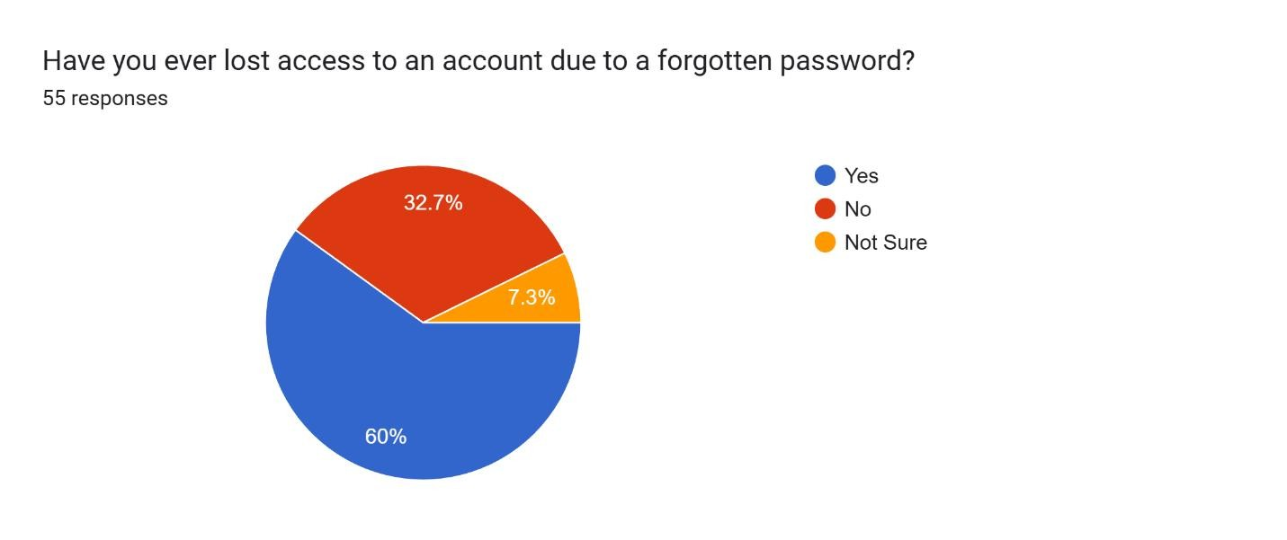
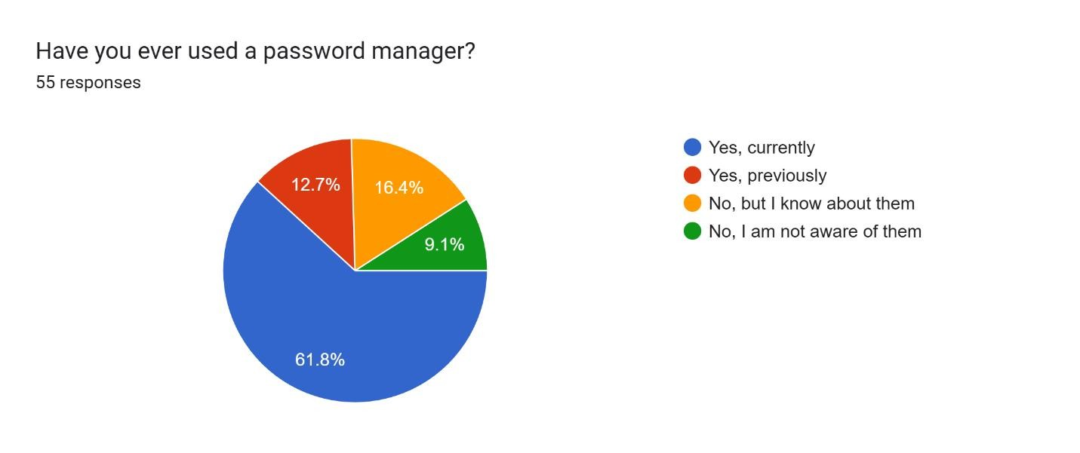
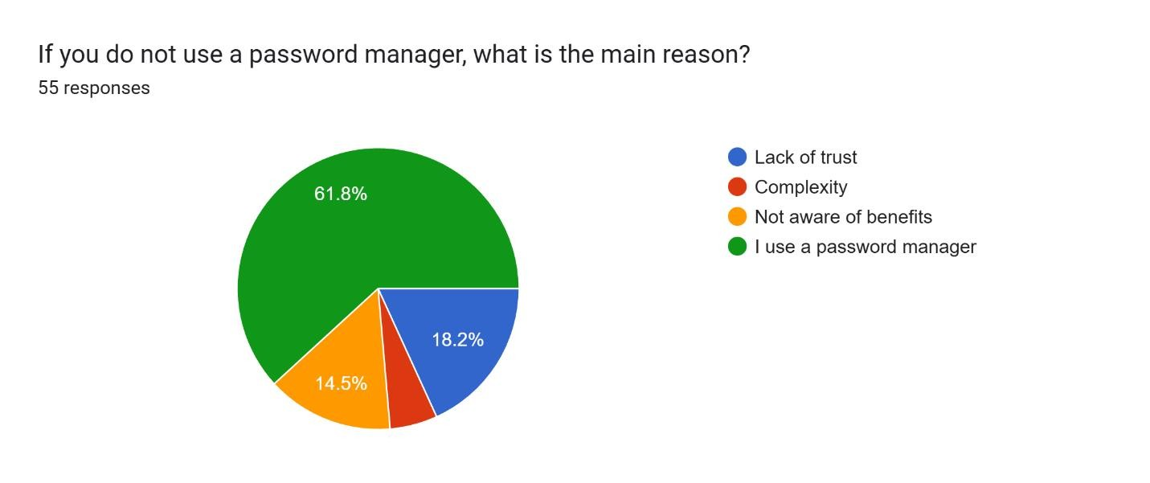
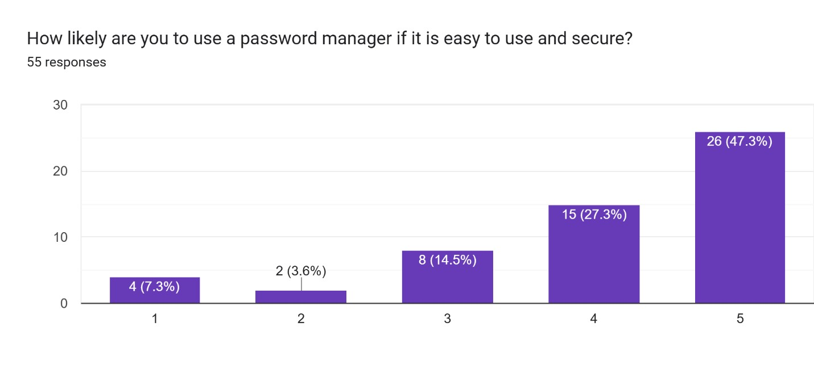
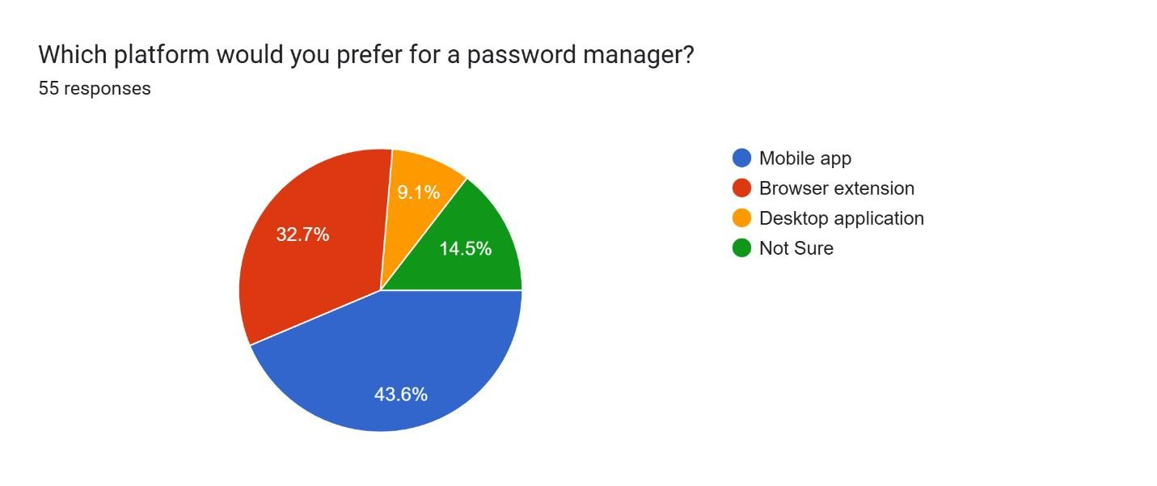
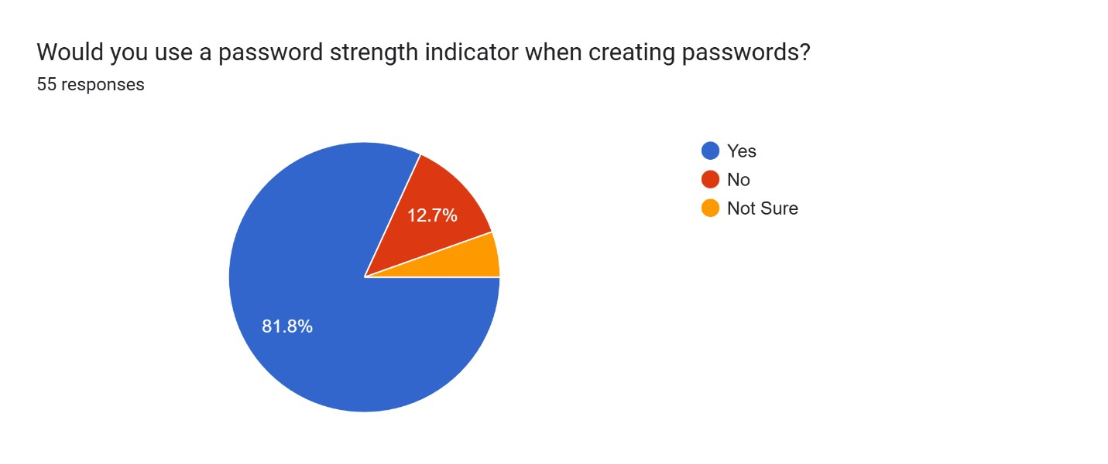
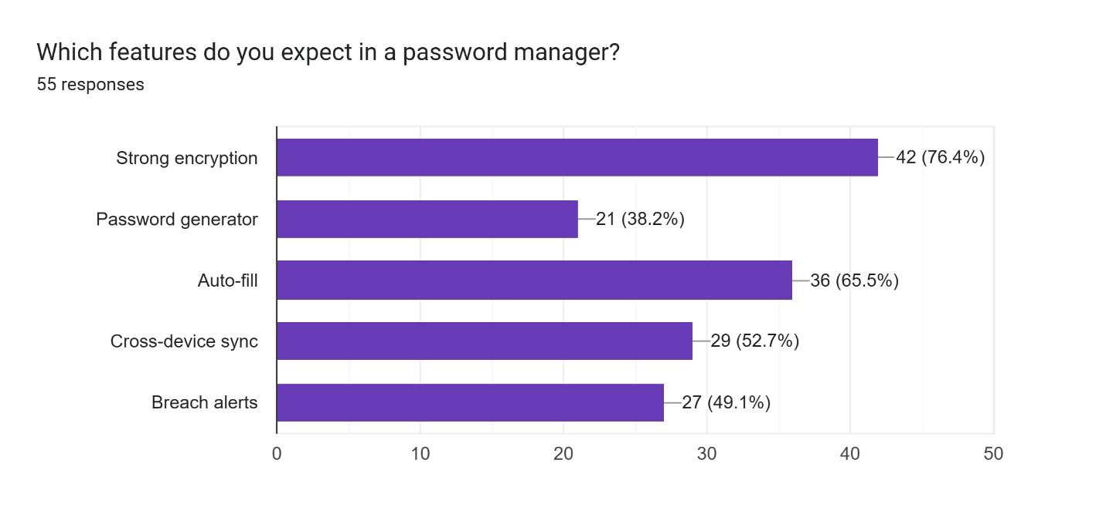
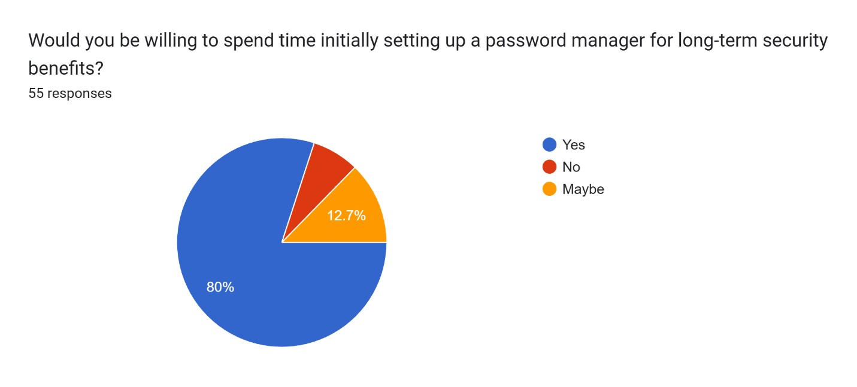
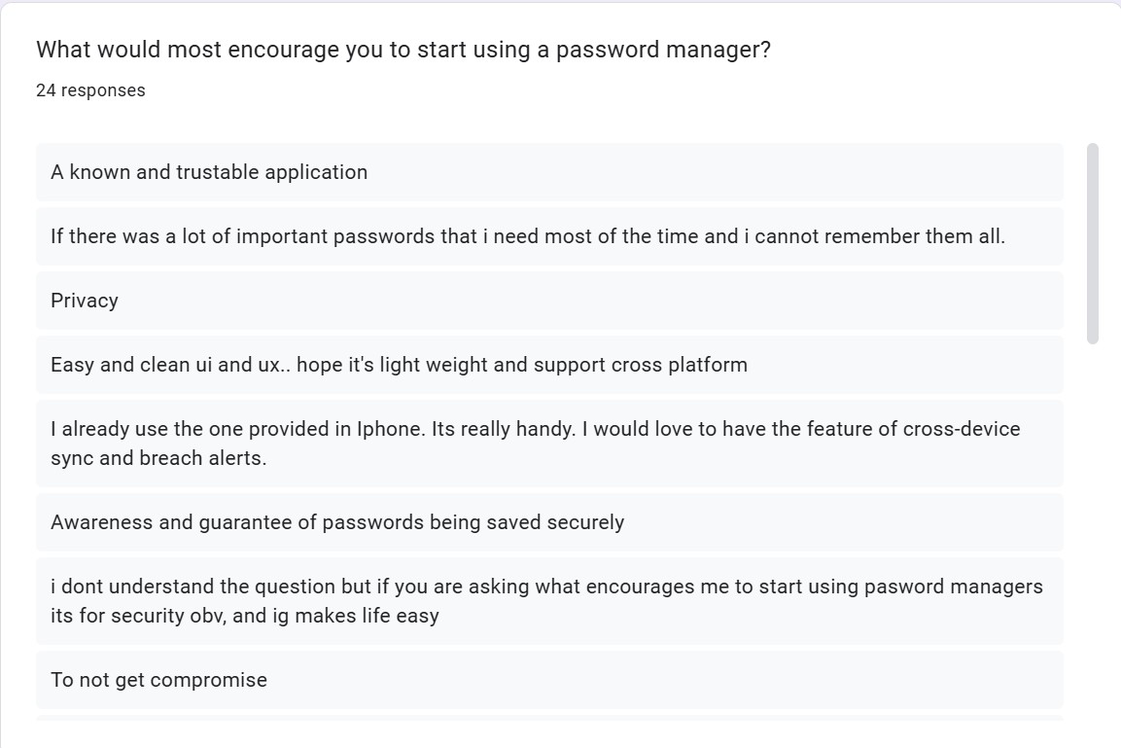
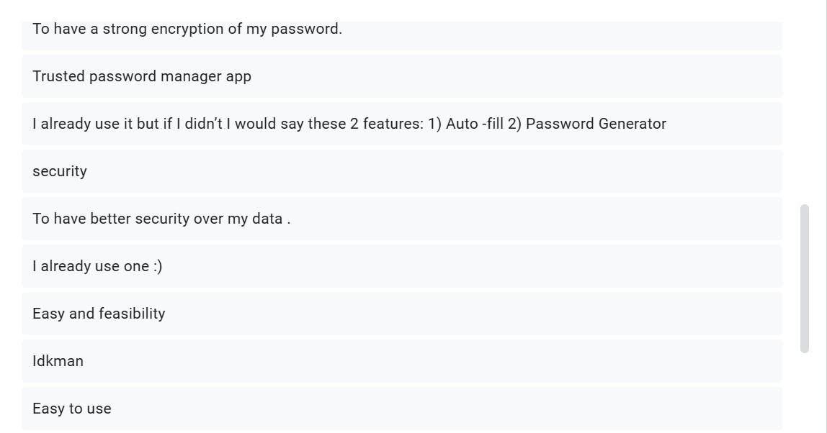
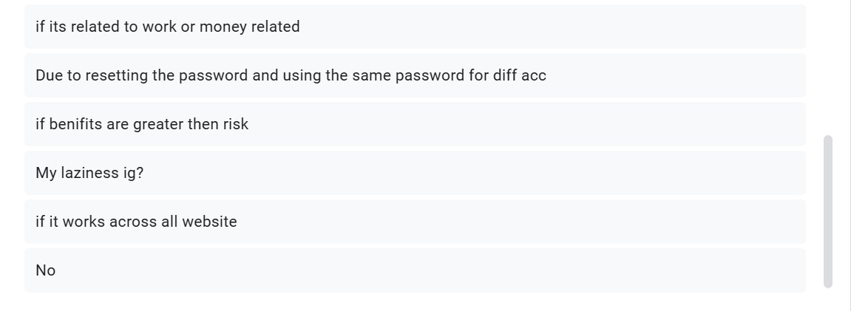

3.3.2. Post-Survey Results
3.5. Requirement Analysis
3.6. Design
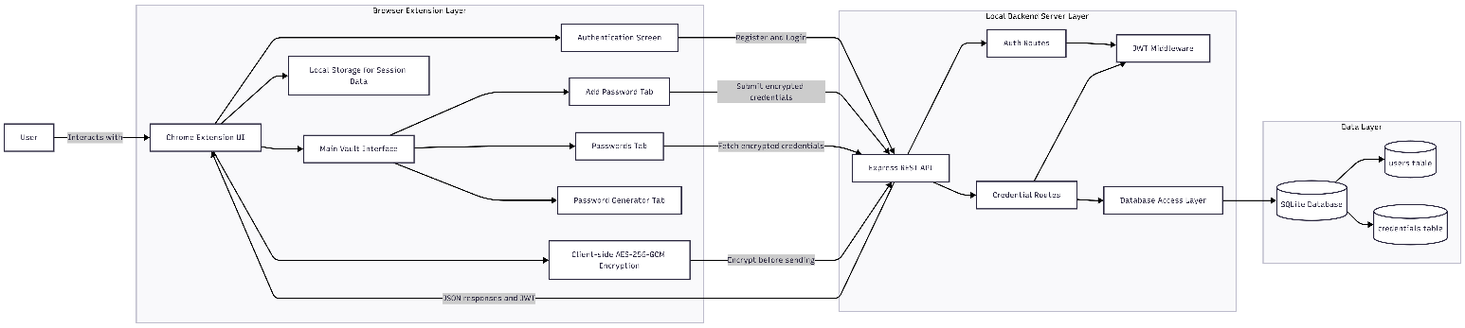
3.7. Implementation

Chapter 4:
Testing and Analysis

4.1. Test Plan

4.1.1. Unit Testing, Test Plan

4.1.2. System Testing, Test Plan

4.2. Unit Testing
Hash String Known value
Field | Details
Test Case ID | UT-01
Module Under Test | hashString (src/utils/crypto.js)
Test Objective | Verify SHA-256 hash output for known string
Pre-conditions | Crypto utils loaded, Test runtime supports Web Crypto
Test Steps | 1) Call hashString("Test123!") 2) Compare with known Hash
Test Input | "Test123!"
Expected Output | 54de7f606f2523cba8efac173fab42fb7f59d56ceff974c8fdb7342cf2cfe345
Actual Output | 54de7f606f2523cba8efac173fab42fb7f59d56ceff974c8fdb7342cf2cfe345
Status | PASS
Remarks | Baseline crypto correctness hash matched.

Field | Details
Test Case ID | UT-02
Module Under Test | hashString (src/utils/crypto.js)
Test Objective | Validate empty string edge case
Test Steps | 1) Call hashString("") 2) Compare with SHA-256 empty digest
Test Input | ""
Expected Output | e3b0c44298fc1c149afbf4c8996fb92427ae41e4649b934ca495991b7852b855
Actual Output | e3b0c44298fc1c149afbf4c8996fb92427ae41e4649b934ca495991b7852b855
Status | PASS
Remarks | Prevent regression on edge input.

Field | Details
Test Case ID | UT-03
Module Under Test | src/utils/crypto.js (getPasswordStrength)
Test Objective | Confirm weak/medium/strong scoring behavior
Test Steps | 1) Call strength function for each 2) Assert scores
Test Input | "abc", "abcdefgh", "Abcdefgh123!"
Expected Output | Password strength scores should be 0, 1, 4 respectively
Actual Output | Scores 0, 1, 4 respectively
Status | PASS
Remarks | Matches existing scoring model.

Field | Details
Test Case ID | UT-04
Module Under Test | src/utils/crypto.js (generatePassword)
Test Objective | Ensure safe failure with no enabled character groups
Test Steps | 1) Call generator 2) Validate return
Test Input | {length:16, upper:false, lower:false, numbers:false, symbols:false}
Expected Output | Returns null
Actual Output | Returns null
Status | PASS
Remarks | Input validation case.

Field | Details
Test Case ID | UT-05
Module Under Test | src/utils/crypto.js (generatePassword)
Test Objective | Validate length and allowed charset
Test Steps | 1) Generate 2) Check length 24 3) Regex validate charset
Test Input | {length:24, upper:true, lower:false, numbers:true, symbols:false}
Expected Output | Generates password as per selected character set.
Actual Output
Status
Remarks | Positive generation path.

4.3. System Testing

4.4. Critical Analysis

Chapter 5: Conclusion

5.1 Legal, Social and Ethical Issues
5.1.1 Legal Issues
5.1.2 Social Issues
5.1.3 Ethical Issues
5.2 Advantages
5.4 Limitations
5.3 Future Work

